Judge Tells N.F.L. to Reveal Some Secrets About Concussions
OCT. 31, 2016

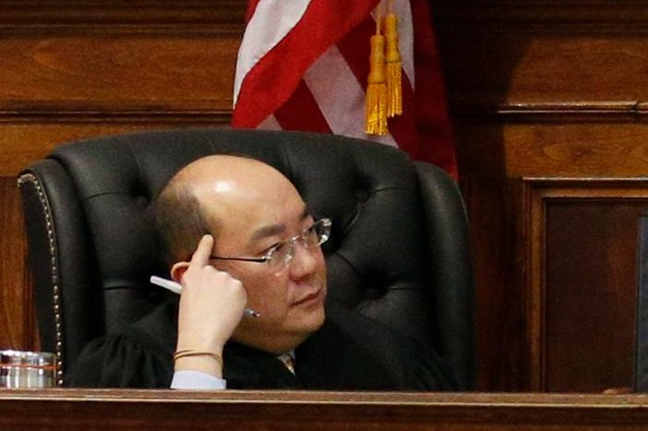
Caption: Justice Jeffrey Oing issued an order that will let insurance companies determine if the N.F.L. knew about the dangers of concussions and deliberately concealed them from players

A New York judge is forcing the N.F.L. to reveal something it has desperately tried to keep secret: how the league’s medical officials handled the issue of brain injuries over the last two decades.

On Monday, Justice Jeffrey K. Oing of New York State Supreme Court issued an order that will let insurance companies that wrote policies for the N.F.L. determine if the league knew about the dangers of concussions and deliberately concealed them from players. The issue is central to whether the insurers will pay for a class-action settlement brought by more than 5,000 retired players who accused the league of fraud and negligence because they were not told about the risks of repeated head hits.

The N.F.L. is likely to appeal Justice Oing’s ruling.

The settlement, which covers all retirees except for a few dozen players who have opted out, has been completed but is under appeal. The league has agreed to pay an unlimited amount of damages to players who have been found to have severe neurological conditions like Parkinson’s disease and Alzheimer’s disease, as well as pay for medical monitoring. Players can each receive up to $5 million, based on their condition, when it was diagnosed and how long they were in the league.

The cost of the settlement could reach $1 billion.

The settlement was reached in August 2013, before plaintiffs’ lawyers could depose witnesses and look through the N.F.L.’s records to determine whether fraud or negligence had been committed.

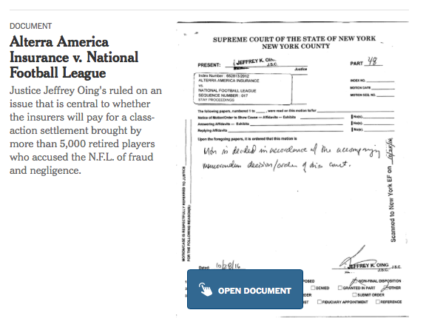

The N.F.L. asked the 30 or so insurers that wrote policies for the league dating to the late 1960s to pay for the settlement, as well as cover its legal costs.

The insurers, though, have refused to pay because they have been unable to determine if the league committed fraud, which they feel would absolve them of responsibility to pay out.

The insurers declined to comment on the judge’s ruling Monday. The N.F.L. did not respond to an email requesting comment.

Justice Oing delayed ruling on the case while the settlement was being completed. In a last-ditch effort, players objecting to the settlement have appealed to the United States Supreme Court. Legal experts consider the appeal a long shot, which is why Justice Oing resumed hearing arguments in the insurance case.

After unsuccessfully pressing the sides to come to an agreement, Justice Oing has now decided to allow the insurers to proceed with discovery, which could unearth damaging records. Most of those records would be treated as confidential, although some could end up appearing in the public court record if the case proceeded to trial.

Even if the N.F.L. appeals Justice Oing’s ruling, the insurers might be allowed to proceed with discovery while the appeal is heard. That could prompt the N.F.L. to settle with the insurers by agreeing to pay for some or all of the settlement, which would ensure that the N.F.L. would not have to disclose what it knew about concussions years ago.

