Report: Judge calls for NFL to reveal concussion secrets for lawsuit
Monday October 31st, 2016

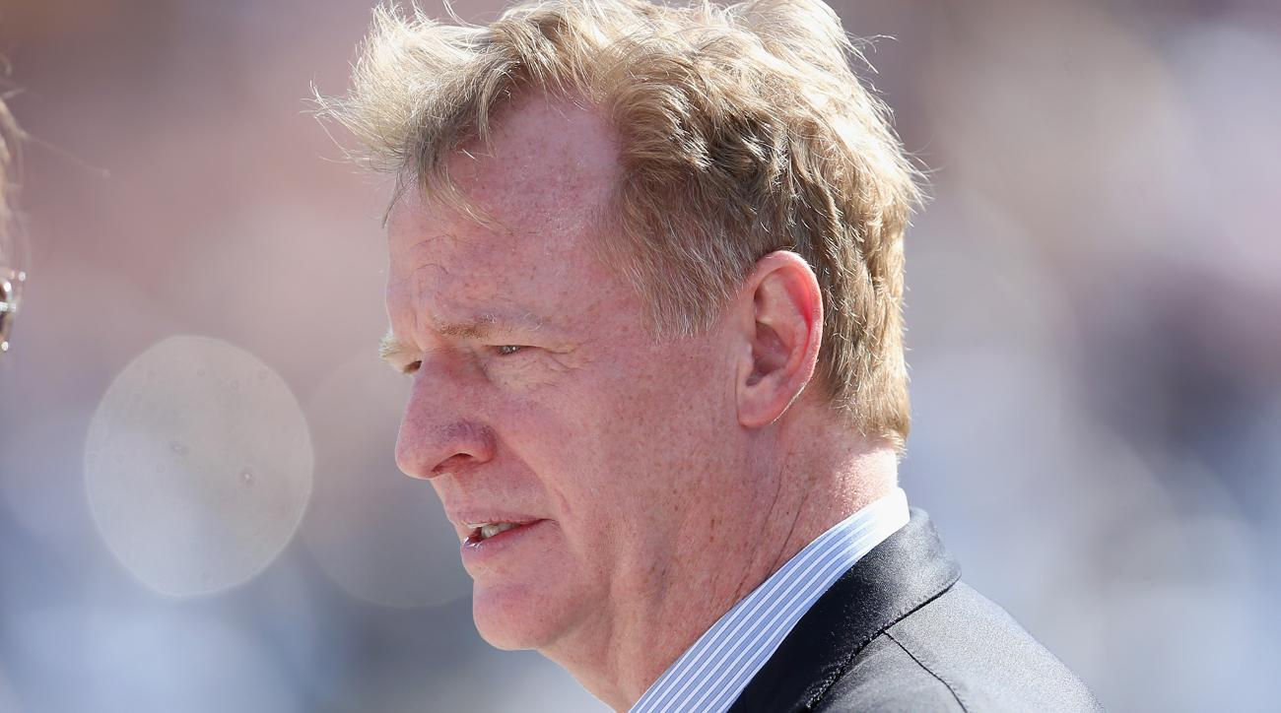
New York State Supreme Court Justice Jeffrey K. Oing has ordered for the NFL to reveal some of the league's information on how medical officials handled brain injuries over the past two decades, according to Ken Belson of the New York Times.

The NFL is expected to appeal Oing's decision.
No caption provided

The ruling comes as more than 5,000 players have filed lawsuits against the NFL accusing the league of fraud and negligence for withholding knowledge about repeated head hits and the repercussions.

A settlement has been completed that would cover all retirees except a few players that have opted out, but it is under appeal. It is estimated that the cost of the settlement could reach $1 billion.

The NFL has agreed to pay for the care of players that have been diagnosed with neurological diseases like Parkinson’s disease and Alzheimer’s disease.

Insurers could reportedly be allowed to proceed with discovery as the NFL appeal is heard. The NFL could reach a settlement in that time, and the information about what the league knew about concussions years ago would not have to be disclosed.

